**Verzeo**

**Microsoft Azure Cloud Computing**

**Assignment-4**

*Name: Aarish Ahmed Siddique*

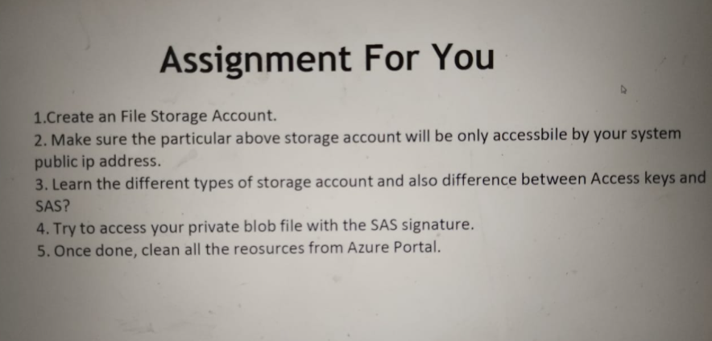

Q1. Created File Storage account

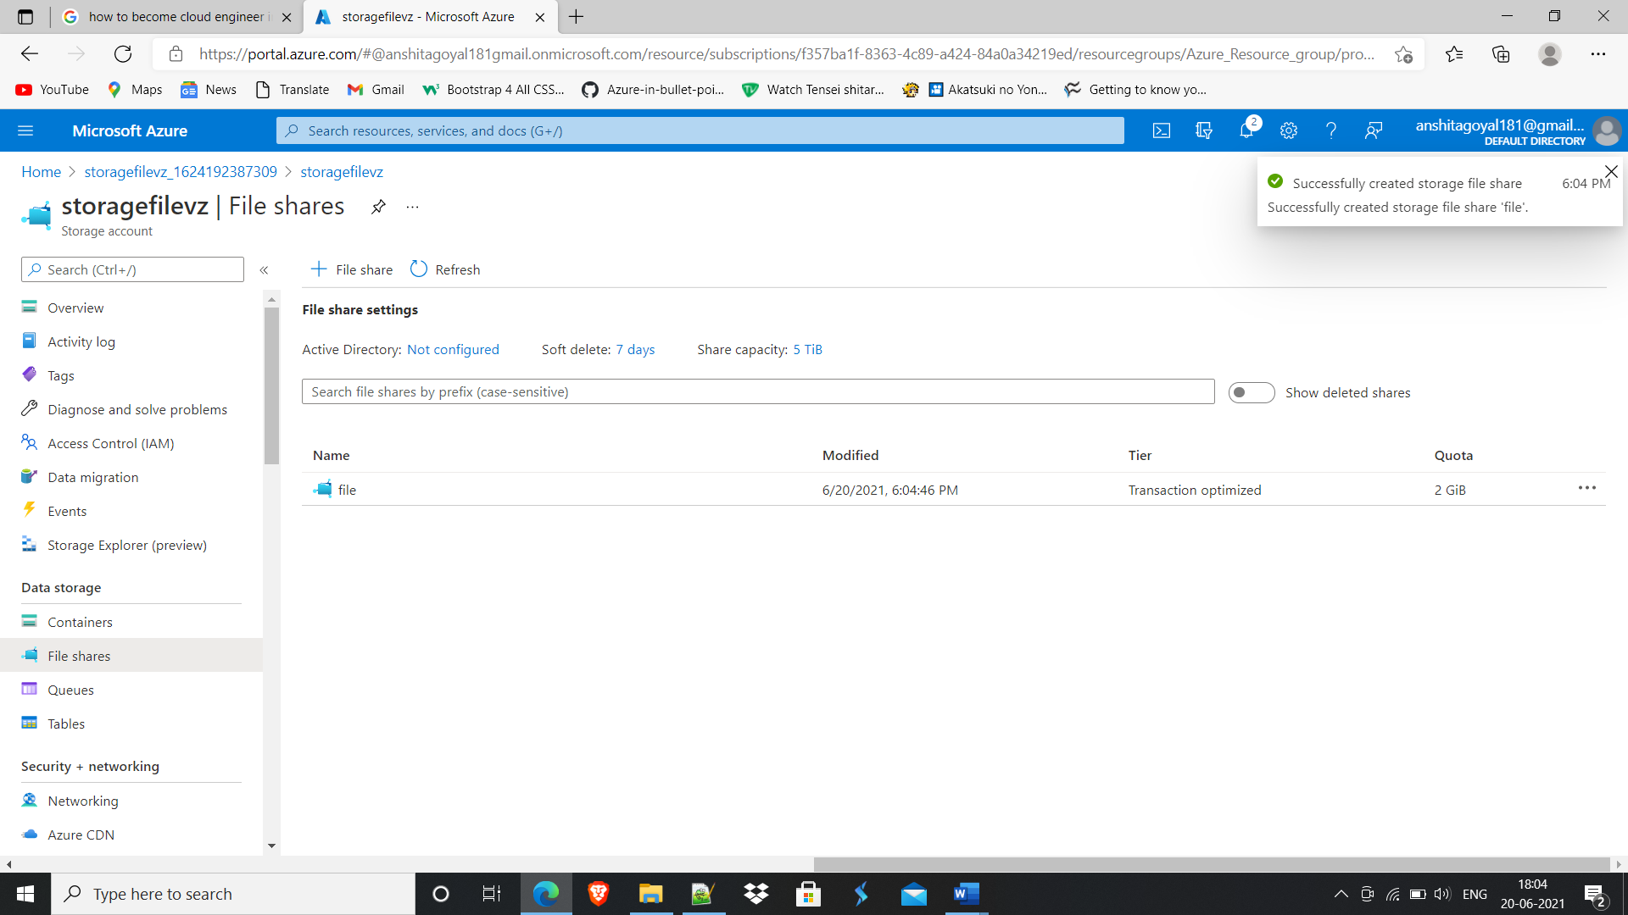

Added my system IP address.

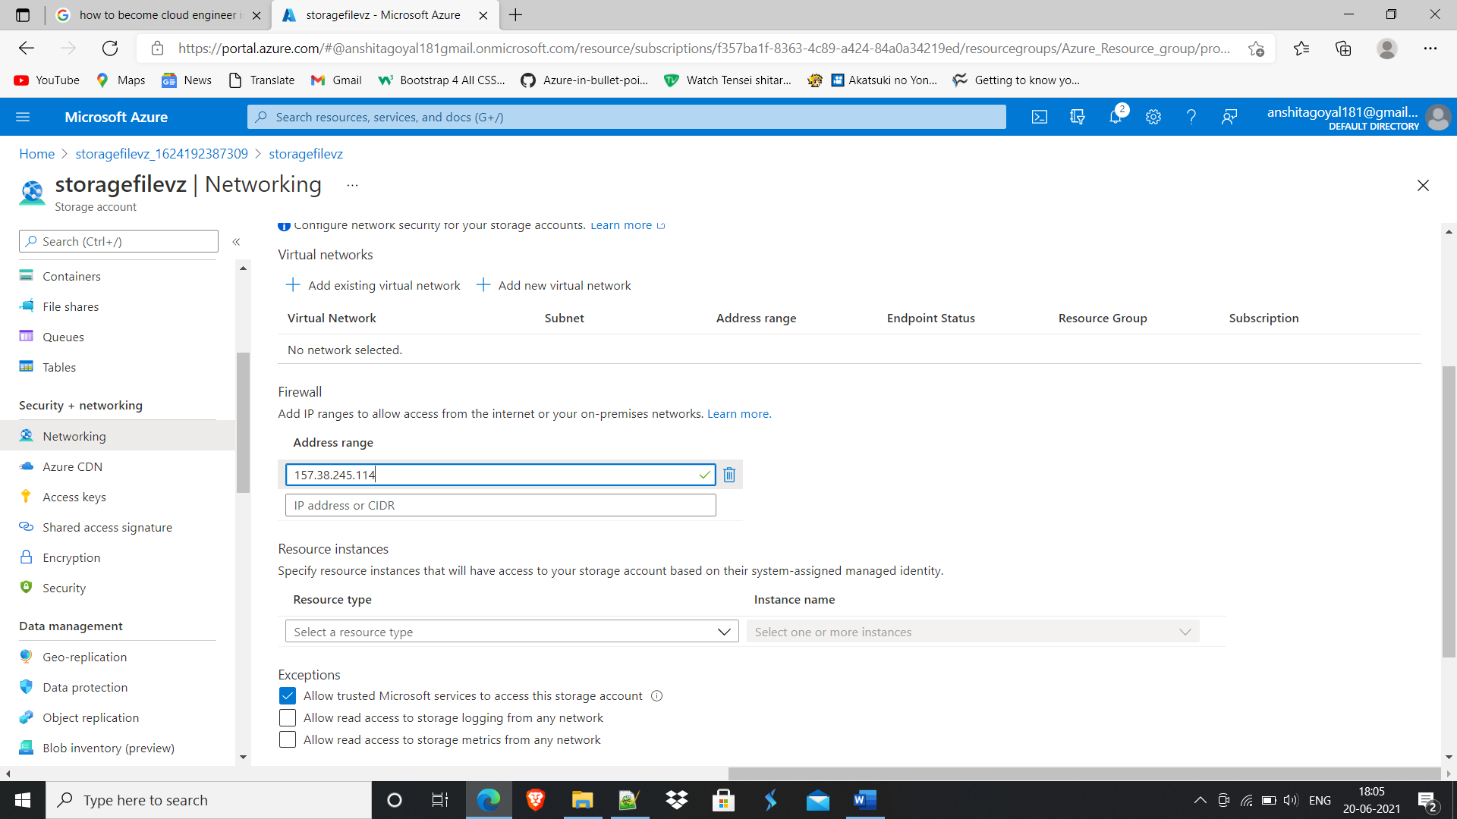

Q3.

**Types of Storage accounts:**

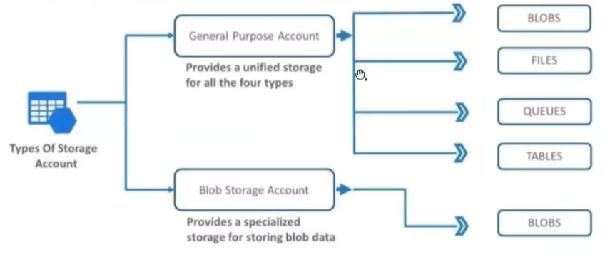

1. Azure Blob storage is designed to store Blobs (or **B**inary **L**arge **Ob**jects) in containers. Blobs are unstructured data such as image, text or binary data files. This is the standard type of storage most Azure components and systems will use to store various binary objects required for your infrastructure.
2. Azure Files storage allows you to setup SMB (Server Message Block) shares within your Azure subscription, allowing multiple VMs to access the same files. This is similar to your on-premises SMB file shares, but with the correct configuration, these files can be accessed from anywhere with working internet.
3. The Azure Queue service is optimised for storing queue messages. These are small messages up to 64KB, stored in queues to be processed asynchronously. This is used more with PaaS components that need a message queue for data processing.
4. Azure Table storage is for storing structured NoSQL data within the cloud. There is also a premium option for storing NoSQL data, should you need it, this is Azure’s NoSQL database Cosmos DB which is used for also storing NoSQL data and offers various APIs.

**Difference between access keys and SAS:**

**Access Keys**:

Every storage account has two keys i.e. key 1 and key 2 along with connection string in order to connect with your application to storage account.

Giving access keys to client means giving full access of storage to client

But if we want to provide particular file access or container access, we will use SAS signature.

**SAS**:

It is a URI which provides restricted access rights to Azure Storage resources

Q4. Created Blob container with private access level.

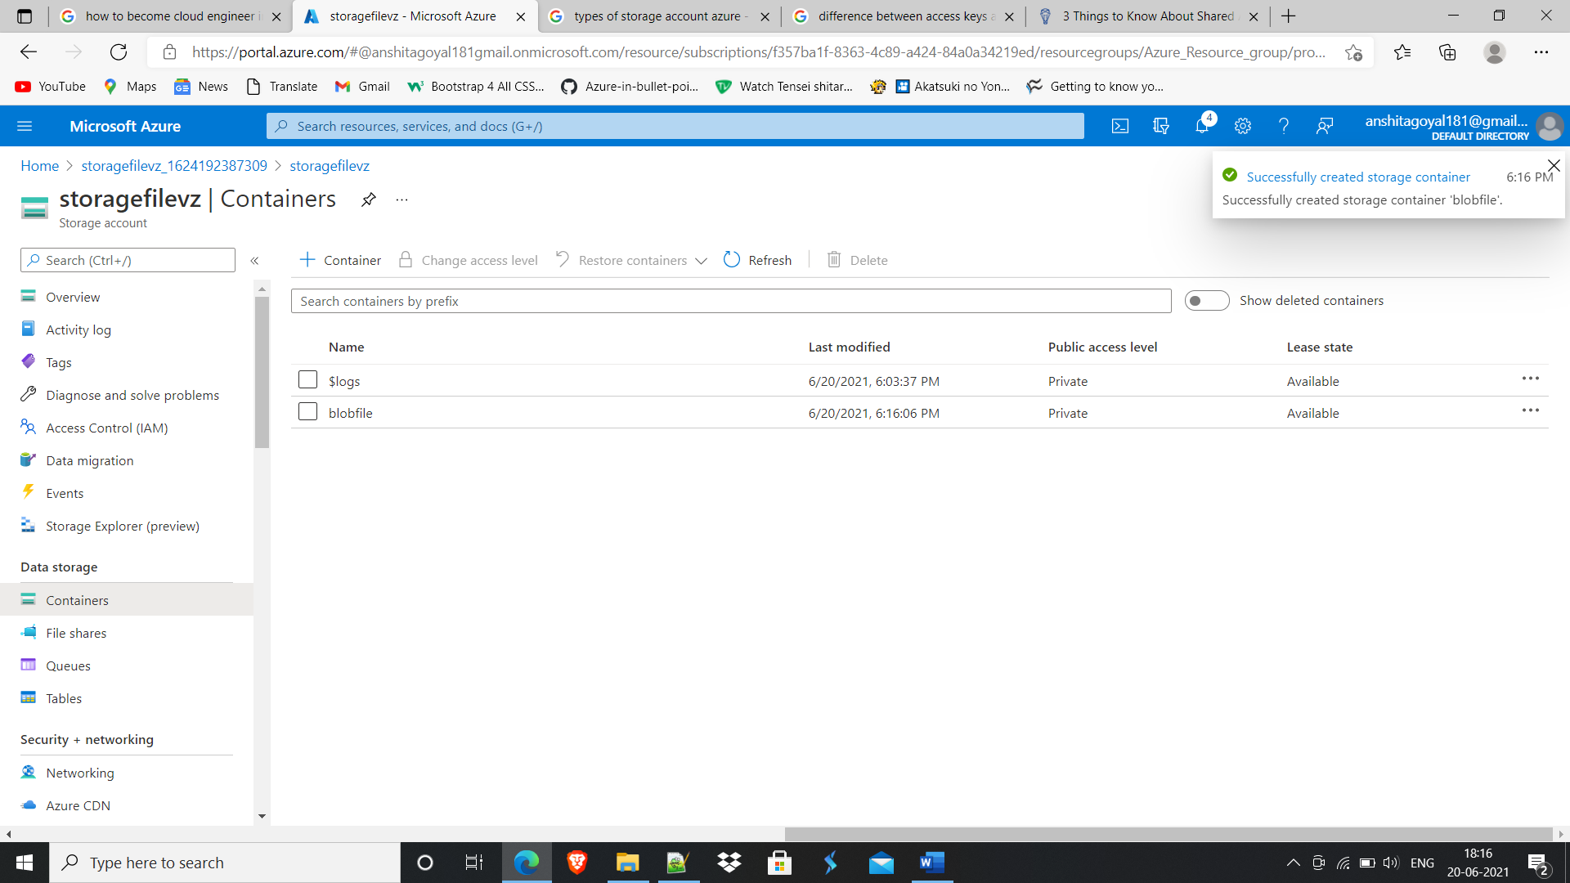

Uploaded File

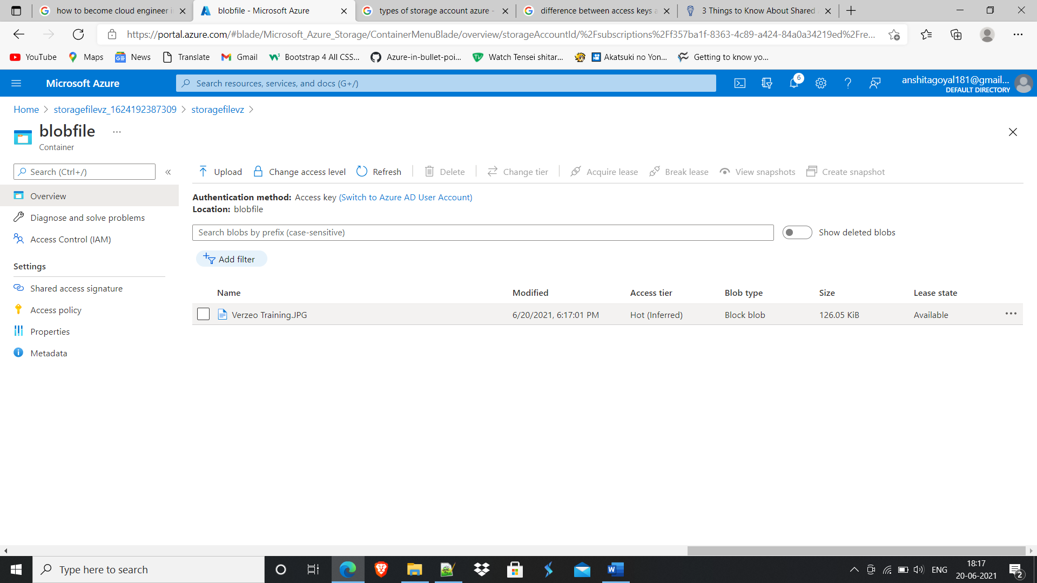

Generated SAS URL and copied to browser new tab.

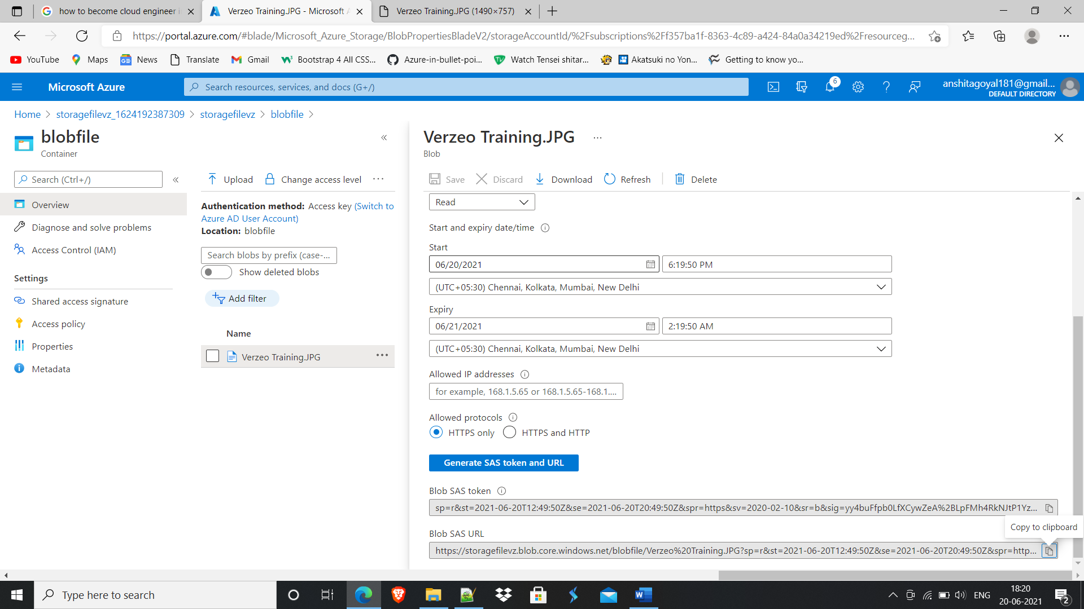

Accessed private blob file through SAS signature.

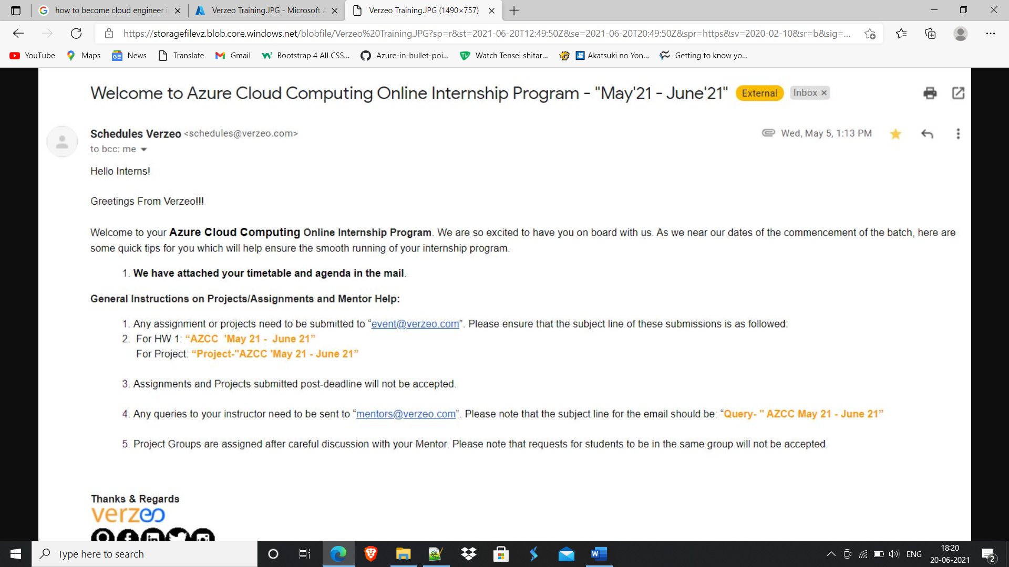

Q5. Deleted all resources

